**OOS LAB  
ASSIGNMENT - 2**



**Name - Anuska Nath**

**Department - Information Technology**

**Roll No - 002311001003**

**Section - A1**

1. Write a program to create two threads. Print “In main thread” in main thread and “In child thread” in child thread.

**Source code :**

class MyThread extends Thread

{

MyThread(){

System.out.println("In child thread");

}

}

class Main

{

public static void main(String args[]){

System.out.println("In main thread");

MyThread ob=new MyThread();

}

}

**Output:**

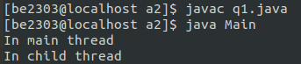

2. Create two threads and call them EvenThread and OddThread. EvenThread will print number as 2 4 6 8 10... and Odd Thread will print number as 1 3 5…. Now, synchronize these two threads to get the output as: 1 2 3 4 5 6 7 8.

**Source Code :**

class PrintNumbers {

private static int counter = 1;

private static final int MAX = 8;

private static final Object lock = new Object();

static class EvenThread extends Thread {

public void run() {

while (counter <= MAX) {

synchronized (lock) {

if (counter % 2 == 0) {

System.out.print(counter + " ");

counter++;

}

lock.notify();

try {

if (counter <= MAX) {

lock.wait();

}

} catch (InterruptedException e) {

e.printStackTrace();

}

}

}

}

}

static class OddThread extends Thread {

public void run() {

while (counter <= MAX) {

synchronized (lock) {

if (counter % 2 != 0) {

System.out.print(counter + " ");

counter++;

}

lock.notify();

try {

if (counter <= MAX) {

lock.wait();

}

} catch (InterruptedException e) {

e.printStackTrace();

}

}

}

}

}

public static void main(String[] args) {

EvenThread evenThread = new EvenThread();

OddThread oddThread = new OddThread();

evenThread.start();

oddThread.start();

try {

evenThread.join();

oddThread.join();

} catch (InterruptedException e) {

e.printStackTrace();

}

}

}

**Output :**



3. Consider the following series x = 1+1/1! +1/2! + 1/3! + ………1/10! Create two threads t1 & t2. t1 will generate the denominators and t2 will form the term and add them up. Finally print the result.

**Source Code :**

public class SeriesSum {

static int currentFactorial;

static boolean ready = false;

static final Object lock = new Object();

public static void main(String[] args) {

Thread t1 = new Thread(() -> {

for (int i = 1; i <= 10; i++) {

int fact = 1;

for (int j = 2; j <= i; j++) fact *= j;

synchronized(lock) {

currentFactorial = fact;

ready = true;

lock.notify();

while(ready) {

try { lock.wait(); }

catch (InterruptedException e) {}

}

}

}

});

Thread t2 = new Thread(() -> {

double sum = 1.0; // Initial value

for (int i = 0; i < 10; i++) {

synchronized(lock) {

while(!ready) {

try { lock.wait(); }

catch (InterruptedException e) {}

}

sum += 1.0 / currentFactorial;

System.out.println("Term " + (i+1) + ": 1/" + currentFactorial + " = " + 1.0 / currentFactorial);

ready = false;

lock.notify();

}

}

System.out.println("Result: " + sum);

});

System.out.println("Term 0: 1 = 1.0");

t1.start();

t2.start();

}

}

**Output :**

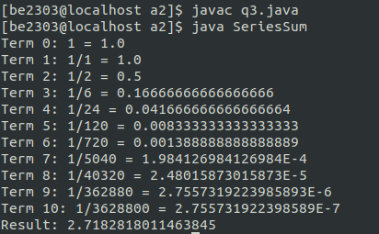

4. Consider a file that contains a number of integers. Create two threads. Call them ‘producer’ and ‘consumer’ thread. Producer thread will be reading the integers from the file continuously while consumer thread will add them up. Use proper synchronization mechanism if needed.

**Source Code :**

import java.io.BufferedReader;

import java.io.FileReader;

import java.io.IOException;

import java.util.LinkedList;

import java.util.Queue;

class SharedBuffer {

private Queue<Integer> buffer = new LinkedList<>();

private final int CAPACITY = 5;

private boolean isProducerDone = false;

synchronized void produce(int number) {

while (buffer.size() == CAPACITY) {

try {

wait();

} catch (InterruptedException e) {

Thread.currentThread().interrupt();

}

}

buffer.offer(number);

System.out.println("Produced: " + number);

notify();

}

synchronized Integer consume() {

while (buffer.isEmpty()) {

if (isProducerDone) {

return null;

}

try {

wait();

} catch (InterruptedException e) {

Thread.currentThread().interrupt();

return null;

}

}

Integer number = buffer.poll();

System.out.println("Consumed: " + number);

notify();

return number;

}

synchronized void setProducerDone() {

isProducerDone = true;

notifyAll();

}

}

class Producer extends Thread {

private SharedBuffer buffer;

private String filename;

Producer(SharedBuffer buffer, String filename) {

this.buffer = buffer;

this.filename = filename;

}

public void run() {

try (BufferedReader reader = new BufferedReader(new FileReader(filename))) {

String line;

while ((line = reader.readLine()) != null) {

int number = Integer.parseInt(line.trim());

buffer.produce(number);

}

buffer.setProducerDone();

} catch (IOException | NumberFormatException e) {

System.out.println("Error reading file: " + e.getMessage());

buffer.setProducerDone();

}

}

}

class Consumer extends Thread {

private SharedBuffer buffer;

private int sum = 0;

Consumer(SharedBuffer buffer) {

this.buffer = buffer;

}

public void run() {

while (true) {

Integer number = buffer.consume();

if (number == null) {

break;

}

sum += number;

}

System.out.println("Final sum: " + sum);

}

public int getSum() {

return sum;

}

}

class FileProcessing {

public static void main(String[] args) {

SharedBuffer buffer = new SharedBuffer();

Producer producer = new Producer(buffer, "numbers.txt");

Consumer consumer = new Consumer(buffer);

producer.start();

consumer.start();

try {

producer.join();

consumer.join();

System.out.println("Processing complete");

} catch (InterruptedException e) {

System.out.println("Main thread interrupted");

}

}

}

 Numbers.txt :

**Output :**

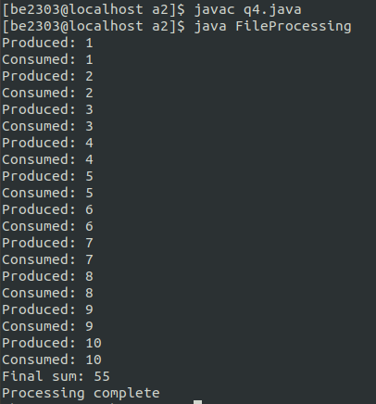

5. Consider the series 1+2+3+…+100. This can be considered as (1+3+5+…+99)+(2+4+6+…+100). Create two threads to compute two series in parallel (do not use simplified equation). Finally print the final sum.

**Source Code :**

class NumSum {

public static double sum=0;

public static boolean ready=false;

static final Object lock = new Object();

static class OddSum extends Thread{

public void run()

{ double os=0;

for (int i=1;i<=100;i+=2)

{

os+=i;

}

synchronized(lock) {

sum+=os;

ready = true;

lock.notify();

while(ready) {

try { lock.wait(); }

catch (InterruptedException e) {}

}

}

}

}

static class EvenSum extends Thread{

public void run()

{ double es=0;

for (int j=2;j<=100;j+=2)

{

es+=j;

}

synchronized(lock) {

while(!ready) {

try { lock.wait(); }

catch (InterruptedException e) {}

}

sum+=es;

ready = false;

lock.notify();

}

}

}

public static void main(String args[]){

OddSum o1=new OddSum();

EvenSum o2=new EvenSum();

o1.start();

o2.start();

try {

o1.join();

o2.join();

} catch (InterruptedException e) {

e.printStackTrace();

}

System.out.println("The final sum is: " + sum);

}

}

**Output :**

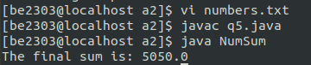

6. Consider the following parallel binary search algorithm for series a1, a2…an sorted in increasing order such that n mod 10 = 0. Element to be searched is e.

a) Create n/10 threads t1, t2,..,tn/10.

b) Distribute the numbers among threads such that ti will have numbers ai, ai+1, ….a2i-1.

c) Distribute the element e to all threads.

d) Each thread searches the element e in its sub-array using binary search algorithm.

Write a Java program using threading technology and print the thread index and location where the element has been found.

**Source Code :**

import java.util.ArrayList;

import java.util.List;

import java.util.concurrent.Callable;

import java.util.concurrent.ExecutorService;

import java.util.concurrent.Executors;

import java.util.concurrent.Future;

class SearchResult {

int threadIndex;

int location;

boolean found;

SearchResult(int threadIndex, int location, boolean found) {

this.threadIndex = threadIndex;

this.location = location;

this.found = found;

}

}

class SearchTask implements Callable<SearchResult> {

private int[] array;

private int target;

private int threadIndex;

private int startOffset;

SearchTask(int[] array, int target, int threadIndex, int startOffset) {

this.array = array;

this.target = target;

this.threadIndex = threadIndex;

this.startOffset = startOffset;

}

private int binarySearch() {

int left = 0;

int right = array.length - 1;

while (left <= right) {

int mid = (left + right) / 2;

if (array[mid] == target) {

return mid + startOffset;

}

if (array[mid] < target) {

left = mid + 1;

} else {

right = mid - 1;

}

}

return -1;

}

public SearchResult call() {

int location = binarySearch();

return new SearchResult(threadIndex, location, location != -1);

}

}

class ParallelBinarySearch {

private static List<SearchTask> createSearchTasks(int[] array, int target, int numThreads) {

List<SearchTask> tasks = new ArrayList<>();

int chunkSize = array.length / numThreads;

for (int i = 0; i < numThreads; i++) {

int[] subArray = new int[chunkSize];

int startIndex = i * chunkSize;

System.arraycopy(array, startIndex, subArray, 0, chunkSize);

tasks.add(new SearchTask(subArray, target, i, startIndex));

}

return tasks;

}

public static void main(String[] args) {

int[] array = {1, 3, 5, 7, 9, 11, 13, 15, 17, 19,

21, 23, 25, 27, 29, 31, 33, 35, 37, 39};

int target = 25;

int numThreads = array.length / 10;

ExecutorService executor = Executors.newFixedThreadPool(numThreads);

List<SearchTask> tasks = createSearchTasks(array, target, numThreads);

try {

List<Future<SearchResult>> futures = executor.invokeAll(tasks);

boolean elementFound = false;

for (Future<SearchResult> future : futures) {

SearchResult result = future.get();

if (result.found) {

elementFound = true;

System.out.printf("Element %d found by Thread %d at location %d%n",

target, result.threadIndex, result.location);

}

}

if (!elementFound) {

System.out.printf("Element %d not found in array%n", target);

}

} catch (Exception e) {

e.printStackTrace();

} finally {

executor.shutdown();

}

}

}

**Output :**

